Database Project – Group 3

**Student Names:**

Bandana Pachabhaiya Magar (C0916126)

Kusum Lamichhane (C0917362)

Ranish Shrestha (C0916260)

Roshan Dhakal (C0916271)

Utsav Bajracharya (C0913555)

**Submitted date:** 11/26/2023

**Table of Contents**

**Part 1 – Company Overview and Product** 1

Company Name 1

Company Overview/Description 1

Products 1

Product Attributes 2

**Part 2 – Customer Sales Invoice** 3

Customer Sales Invoice 3

**Part 3 – Database Design** 4

ER diagram 4

Relational Model 5

Relational Schema 7

Business Rules 8

**Part 4 – Constraint Testing** 9

Employee Table 9

Product Table 11

Customer Table 12

Order Table 13

Order_Items Table 14

Company Table 16

Warehouse Table 18

Category Table 19

Inventory Table 19

**Table of Figures**

Figure 1 Product Attributes 2

Figure 2 ER diagram 4

Figure 3 Checking Primary Key Constraint for Employee_Id 9

Figure 4 Checking DataType Constraint for Middle_Name 9

Figure 5 Checking Check Constraint for Gender 9

Figure 6 Checking Unique Key Constraint for Email 9

Figure 7 Checking Foreign Key Constraint for Manager_Id 10

Figure 8 Checking Foreign Key Constraint for Warehouse 10

Figure 9 Checking Default Constraint for Hire_Date 10

Figure 10 Checking Not Null Constraint – Product 11

Figure 11 Checking Foreign Key Constraint - Product 11

Figure 12 Checking Unique Key Constraint – Product 11

Figure 13 Checking Primary Key Constraint 12

Figure 14 Checking Unique Key Constraint for Username 12

Figure 15 Checking Unique Key Constraint for Email 12

Figure 16 Checking Gender Constraint 13

Figure 17 Checking Unique Key Constraint for Mobile_Number 13

Figure 18 Checking Primary Key Constraint for Order_Id 13

Figure 19 Checking Foreign Key Constraint for Customer_Id 14

Figure 20 Checking Unique Key Constraint for Tracking_Number 14

Figure 21 Checking Primary Key Constraint 14

Figure 22 Checking Foreign Key Constraint for Order_Id 15

Figure 23 Checking Foreign Key Constraint for Product_Id 15

Figure 24 Checking Not Null Constraint for Quantity 15

Figure 25 Checking Not Null Constraint for Discount 15

Figure 26 Checking Primary Key Constraint for Company_Id 16

Figure 27 Checking Unique Key Constraint for Name 16

Figure 28 Checking Unique Key Constraint for Phone_Number 17

Figure 29 Checking Unique Key Constraint for Email 17

Figure 30 Checking Primary Key Constraint for Warehouse_Id 18

Figure 31 Checking Foreign Key Constraint for Warehouse_Manager_Id 18

Figure 32 Checking Unique Key Constraint for Email 18

Figure 33 Checking Primary Key Constraint for Category_Id 19

Figure 34 Checking Unique Key Constraint for Name 19

Figure 35 Checking Primary Key Constraint for Inventory_Id 19

Figure 36 Checking Foreign Key Constraint for Warehouse_Id 19

Figure 37 Checking Foreign Key Constraint for Product_Id 20

Figure 38 Checking Unique Key Constraint for Shelves_Number 20

# **Part 1 – Company Overview and Product**

## Company Name

Oasis Hardware

## Company Overview/Description

Oasis Hardware Company specialize in the design, manufacturing, and distribution high-quality of different hardware products. It has consistently delivered different hardware solutions, and exceptional services and gained customer satisfaction. Our mission is to become the oasis of reliability in the hardware industry where people can find the perfect hardware solution that meets their needs, backed by strong support and services. Innovation is continuously run in Oasis Hardware Company where our research and development team constantly explore new technology, materials, and design to create more reliable solutions. We value customer feedback and continuously refine our products and services.

## Products

Oasis Hardware company provides a wide range of goods and equipment for building, house renovation, maintenance, and repair. Our goal is to offer top-notch hardware solutions to a variety of sectors and uses. The products we have are known for their quality and reliability. Here are some of the products offered by our company:

**Safety Gears department** – In this department, we store safety gear and equipment to prioritize worker safety. We have everything you need, such as safety helmets, gloves, dust masks, knee pads, work boots, ear protection, eye protection.

**Electrical Supply department** – Electrical tools, Extension cords, Switches, Circuit breakers, Wiring, Electrical outlets, Electrical connectors.

**Paint and painting supplies** – Paint color, Paint brushes, Rollers, Drop cloths, Painter tape and Paint trays.

**Home appliances** – Flooring (Tiles, Laminate, Hardwood), locks, knobs, handles, shelving, and organizers for cabinets.

## Product Attributes

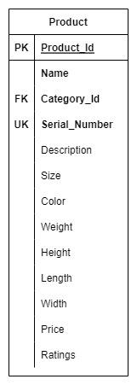

Figure Product Attributes

# **Part 2 – Customer Sales Invoice**

## Customer Sales Invoice

**Customer ID**: 0001 **Order ID**: 00001

**Customer Name**: ABCD Company **Order Date**: 05/11/2023

**Customer Address**: 333 N Rivermede Rd **Associate ID**: 501

Toronto, ON L4K 3N7 **Associate Name**: Bob Smith

|  |  |  |  |  |  |  |
| --- | --- | --- | --- | --- | --- | --- |
|  |  |  |  |  |  |  |
| **Product ID** | **Model** | **Brand** | **Description** | **Qty** | **Unit Price** | **Extended Price** |
| S011 | 62-12345 | Lawn-Boy | Helmets | 2 | 595.00 | 1190.00 |
| E668 | 59-98765 | Black & Decker | Switches | 1 | 1449.00 | 1449.00 |
| P763 | 36-59278 | Craftsman | Paint and brush | 2 | 625.00 | 1250.00 |
| H004 | 45-78233 | Craftsman | Locks | 1 | 150.00 | 150.00 |
|  |  |  |  |  |  |  |
|  |  |  |  |  |  |  |
|  |  |  |  |  | **Sub-total** | 4039.00 |
|  |  |  |  |  | **Tax** | 525.07 |
|  |  |  |  | **Invoice Total** | | 4,564.07 |

**Customer ID**: 0002 **Order ID**: 00002

**Customer Name**: XYZ Company **Order Date**: 07/11/2023

**Customer Address**: 1120 Newkirk Rd **Associate ID**: 502

Toronto, ON L4K 3N7 **Associate Name**: Robin

|  |  |  |  |  |  |  |
| --- | --- | --- | --- | --- | --- | --- |
|  |  |  |  |  |  |  |
| **Product ID** | **Model** | **Brand** | **Description** | **Qty** | **Unit Price** | **Extended Price** |
| S011 | 62-12345 | Lawn-Boy | Knee Pads | 10 | 200.00 | 2000.00 |
| E668 | 59-98765 | Black & Decker | Switches | 1 | 1449.00 | 1449.00 |
| E700 | 36-59278 | Craftsman | Electric Connectors | 2 | 625.00 | 1250.00 |
| H004 | 45-78233 | Craftsman | Locks | 1 | 150.00 | 150.00 |
|  |  |  |  |  |  |  |
|  |  |  |  |  |  |  |
|  |  |  |  |  | **Sub-total** | 4849.00 |
|  |  |  |  |  | **Tax** | 630.37 |
|  |  |  |  | **Invoice Total** | | 5,479.37 |

Product id:

**Safety Gears department** – S

**Electrical Supply department** – E

**Paint and painting supplies** – P

**Home appliances** – H

# **Part 3 – Database Design**

## ER diagram

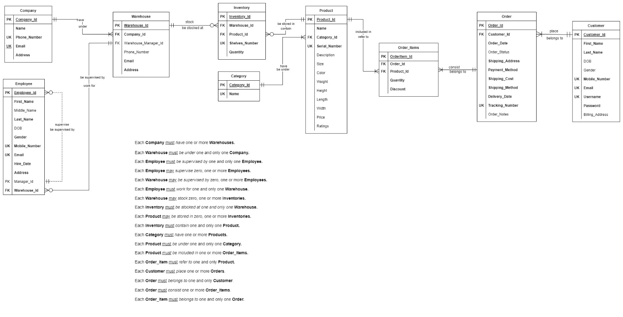

Figure ER diagram

*Figure SEQ Figure \* ARABIC 4 Customers ER Diagram*

## Relational Model

|  |  |  |  |  |  |
| --- | --- | --- | --- | --- | --- |
| PRODUCTS | | | | | |
| Key Type | Optionality | Column Name | Data Type | Length | Constraints |
| PK | * | Product_Id | integer |  | Unique identifier |
|  | * | Name | varchar | (20) |  |
| FK | * | Category_Id | integer |  | Must be a valid category |
| UK | * | Serial_number | character | (15) | Unique identifier |
|  | 0 | Description | varchar | (100) |  |
|  | 0 | Size | integer |  |  |
|  | 0 | Color | varchar | (20) |  |
|  | 0 | Weight | decimal | (5,2) |  |
|  | 0 | Height | decimal | (3,2) |  |
|  | 0 | Length | decimal | (3,2) |  |
|  | 0 | Width | decimal | (3,2) |  |
|  | 0 | Price | decimal | (10,2) |  |
|  | 0 | Ratings | decimal | (2,1) |  |

|  |  |  |  |  |  |
| --- | --- | --- | --- | --- | --- |
| WAREHOUSES | | | | | |
| Key Type | Optionality | Column Name | Data Type | Length | Constraints |
| PK | * | Warehouse_Id | integer |  | Unique identifier |
| FK | * | Company_Id | integer |  | Must be a valid company |
| FK | 0 | Warehouse_Manager_Id | integer |  | Must be a valid employee |
|  | 0 | Phone_Number | varchar | (10) |  |
| UK | * | Email | varchar | (50) | Unique identifier |
|  | * | Address | varchar | (50) |  |

|  |  |  |  |  |  |
| --- | --- | --- | --- | --- | --- |
| INVENTORY | | | | | |
| Key Type | Optionality | Column Name | Data Type | Length | Constraints |
| PK | * | Inventory_Id | integer |  | Unique identifier |
| FK | * | Warehouse_Id | integer |  | Must be a valid warehouse |
| FK | * | Product_Id | integer |  | Must be a valid product |
| UK | * | Shelves_Number | integer |  | Unique identifier |
|  | * | Quantity | decimal | (10, 2) |  |

|  |  |  |  |  |  |
| --- | --- | --- | --- | --- | --- |
| COMPANY | | | | | |
| Key Type | Optionality | Column Name | Data Type | Length | Constraints |
| PK | * | Company_Id | integer |  | Unique identifier |
| UK | * | Name | varchar | (50) | Unique identifier |
| UK | * | Phone_Number | integer |  | Unique identifier |
| UK | * | Email | varchar | (50) | Unique identifier |
|  | * | Address | varchar | (20) |  |

|  |  |  |  |  |  |
| --- | --- | --- | --- | --- | --- |
| EMPLOYEES | | | | | |
| Key Type | Optionality | Column Name | Data Type | Length | Constraints |
| PK | * | Employee_Id | integer |  | Unique identifier |
|  | * | First_Name | varchar | (10) |  |
|  | 0 | Middle_Name | character | (1) |  |
|  | * | Last_Name | varchar | (10) |  |
|  | * | DOB | date |  |  |
|  | * | Gender | character | (1) | Must be 'M', 'F', or 'O' |
| UK | * | Mobile_Number | varchar | (10) | Unique identifier |
| UK | * | Email | varchar | (50) | Unique identifier |
|  | * | Hire_Date | Date |  | * If unknown, use current date. * Must be greater than birth date |
|  | * | Address | varchar | (50) |  |
| FK | 0 | Manager_Id | integer |  | Must be a valid employee |
| FK | * | Warehouse_Id | integer |  | Must be a valid warehouse |

|  |  |  |  |  |  |
| --- | --- | --- | --- | --- | --- |
| CUSTOMERS | | | | | |
| Key Type | Optionality | Column Name | Data Type | Length | Constraints |
| PK | * | Customer_Id | integer |  | Unique identifier |
|  | * | First_Name | varchar | (10) |  |
|  | * | Last_Name | varchar | (10) |  |
|  | 0 | DOB | date |  |  |
|  | 0 | Gender | character | (1) | Must be ‘M’, ‘F’, or ‘O’ |
| UK | * | Mobile_Number | varchar | (10) | Unique identifier |
| UK | * | Email | varchar | (50) | Unique identifier |
| UK | * | Username | varchar | (10) | Unique identifier |
|  | * | Password | varchar | (12) |  |
|  | 0 | Billing_Address | varchar | (50) |  |

|  |  |  |  |  |  |
| --- | --- | --- | --- | --- | --- |
| ORDERS | | | | | |
| Key Type | Optionality | Column Name | Data Type | Length | Constraints |
| PK | * | Order_Id | integer |  | Unique identifier |
| FK | * | Customer_Id | integer |  | Must be a valid Customer |
|  | * | Order_Date | date |  |  |
|  | 0 | Order_Status | varchar | (8) |  |
|  | * | Shipping_Address | varchar | (50) |  |
|  | * | Payment_Method | varchar | (8) |  |
|  | * | Shipping_Cost | decimal | (10, 2) |  |
|  | * | Delivery_Date | date |  |  |
|  | * | Shipping_Method | varchar | (8) |  |
| UK | * | Tracking_Number | varchar | (10) | Unique identifier |
|  | 0 | Order_Notes | varchar | (50) |  |

|  |  |  |  |  |  |
| --- | --- | --- | --- | --- | --- |
| ORDER_ITEMS | | | | | |
| Key Type | Optionality | Column Name | Data Type | Length | Constraints |
| PK | * | OrderItem_Id | integer |  | Unique identifier |
| FK | * | Order_Id | integer |  | Must be a valid order |
| FK | * | Product_Id | integer |  | Must be a valid product |
|  | * | Quantity | decimal | (10, 2) |  |
|  | * | Discount | decimal | (10, 2) |  |

|  |  |  |  |  |  |
| --- | --- | --- | --- | --- | --- |
| CATEGORY | | | | | |
| Key Type | Optionality | Column Name | Data Type | Length | Constraints |
| PK | * | Category_Id | integer |  | Unique identifier |
| UK | * | Name | varchar | (50) | Unique identifier |

## Relational Schema

PRODUCT(**Product_Id**, Name, *Category_Id*, Serial_Number, Description, Size, Color, Weight, Height, Length, Width, Price, Ratings)

FK *Category_Id* -> CATEGORY

WAREHOUSE(**Warehouse_Id** *Warehouese_Manager_Id*, Phone_Number, Email, *Postal_Code*, Address)

FK *Warehouese_Manager_Id* -> EMPLOYEE

FK *Postal_Code* -> POSTAL_ ADDRESS

INVENTORY(**Inventory_Id**, *Warehouse_Id*, *Product_Id*, *Department_Id*, Shelves_Number Quantity, DiscountAmount)

FK *Warehouse_Id* -> WAREHOUSE

FK *Product_Id* -> PRODUCT

FK *Department_Id* -> DEPARTMENT

DEPARTMENT(**Department_Id**, Name)

COMPANY(**Company_Id**, Name, Phone_Number, Email, *Postal_Code*, Address)

FK *Postal_Code* -> POSTAL_ ADDRESS

POSTAL_ADDRESS(**Postal_Id**, Postal_Code, City, State, Country)

EMPLOYEE(**Employee_Id**, First_Name, Middle_Name, Last_Name, DOB, Gender, Mobile_Number, Email, Hire_Date, *Postal_Code*, Address, *Manager_Id*, *Department_Id, Warehouse_Id*)

FK *Postal_Code* -> POSTAL_ ADDRESS

FK *Department_Id* -> DEPARTMENT

FK *Manager_Id* -> EMPLOYEE

FK *Warehouse_Id* -> WAREHOUSE

CUSTOMERS(**Customer_Id**, First_Name, Last_Name, DOB, Gender, Mobile_Number, Email, Username, Password, Billing_Address)

ORDER(**Order_Id**, *Customer_Id*, Order_Date, Order_Status, Shipping_Address, Payment_Method, Shipping_Cost, Shipping_Method, Delivery_Date, Tracking_Number, Order_Notes)

FK *Customer_Id* -> CUSTOMER

ORDER_ITEMS(**OrderItem_Id**, *Order_Id*, *Product_Id,* Quantity, Discount)

FK *Order_Id* -> ORDER

FK *Product_Id* -> PRODUCT

CATEGORY(**Category_Id**, Name)

## Business Rules

Business rules for Oasis Hardware Company can help establish guidelines and standards for various aspects of your business operations. Here are some business rules of Oasis Hardware Company:

* A company has different types of products with different attributes.
* Company can have one or many warehouses.
* Products are kept in a warehouse for sale. Some products might not be available for sale.
* The company has a few employees. Each employee, except the CEO, is supervised by one manager.
* All managers are employees, but all employees are not managers.
* Each manager may supervise many employees.
* A manager may not have any employees reporting to him/her.
* Products are categorized into different categories.
* Some departments might only be categorized in the warehouse to store or display products.
* Each employee should work for at least one department.
* Customer should make one or more orders.
* Customer can make the same Orders once or many times.
* Customer can place an order for the same product or a different one.
* Quantity for an order should be one at least.
* Each employee should work for one warehouse. There should be a manager at warehouse.
* Each warehouse may have one or many employees to work for.

# **Part 4 – Constraint Testing**

## Employee Table

Figure Checking Primary Key Constraint for Employee_Id

Figure Checking DataType Constraint for Middle_Name

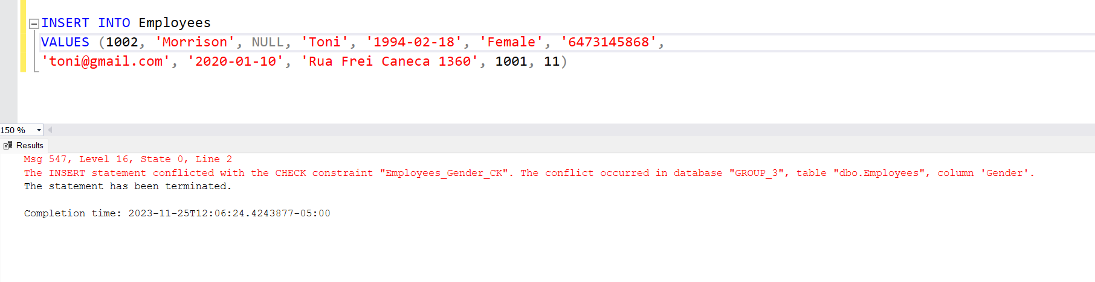

Figure Checking Check Constraint for Gender

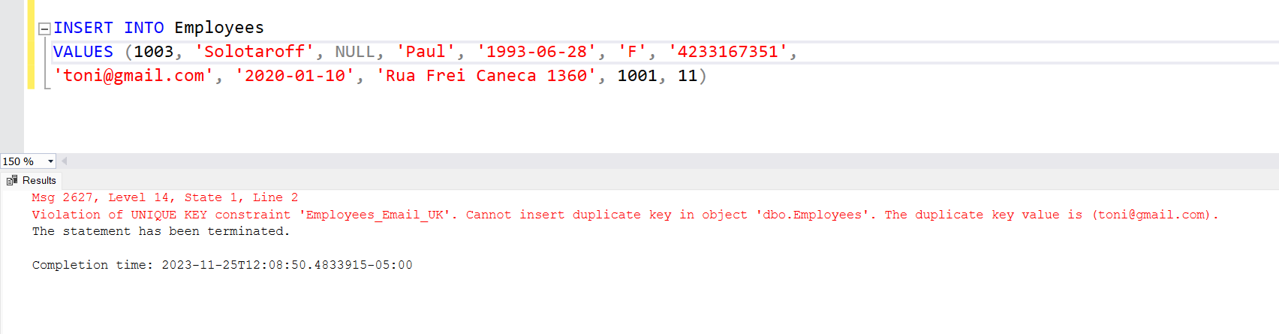

Figure Checking Unique Key Constraint for Email

Figure Checking Foreign Key Constraint for Manager_Id

Figure Checking Foreign Key Constraint for Warehouse

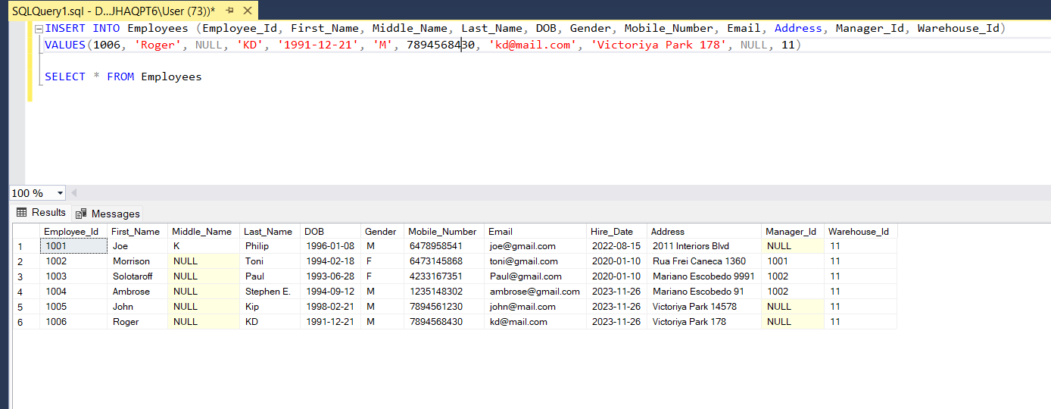

Figure Checking Default Constraint for Hire_Date

## Product Table

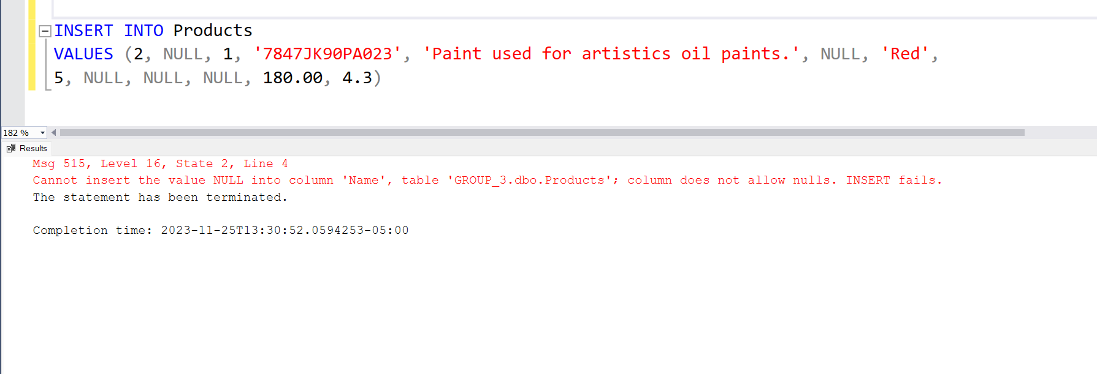

Figure Checking Not Null Constraint – Product

Figure Checking Foreign Key Constraint - Product

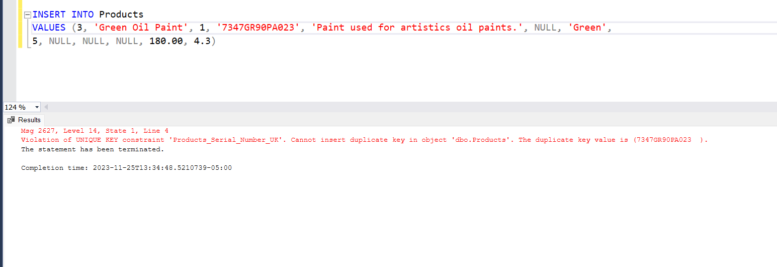

Figure Checking Unique Key Constraint – Product

## Customer Table

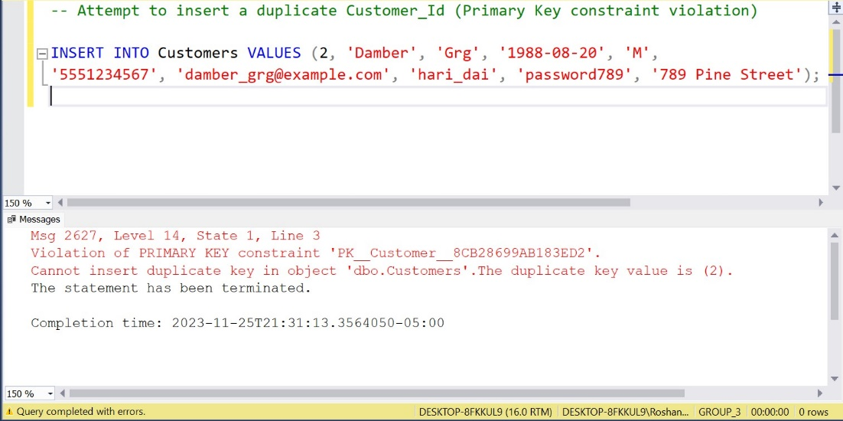

Figure Checking Primary Key Constraint

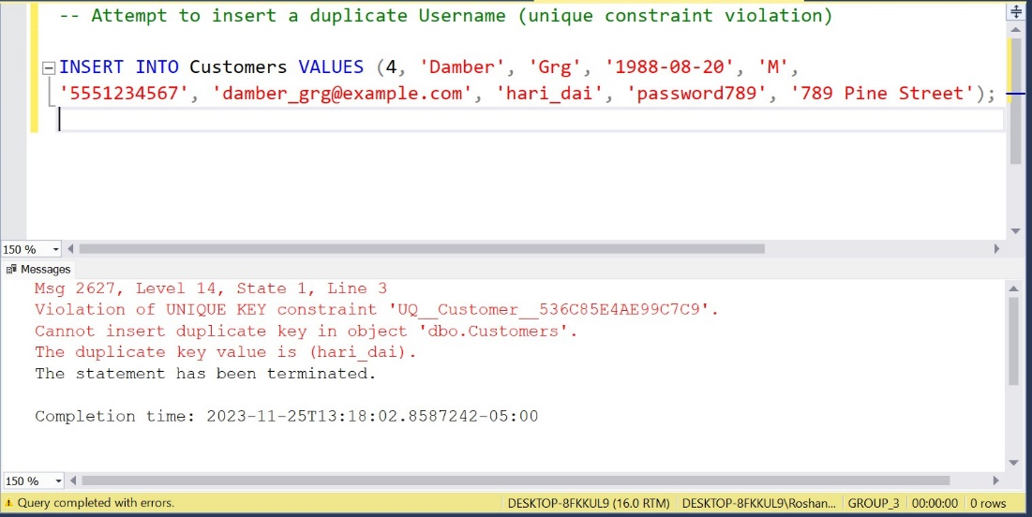

Figure Checking Unique Key Constraint for Username

Figure Checking Unique Key Constraint for Email

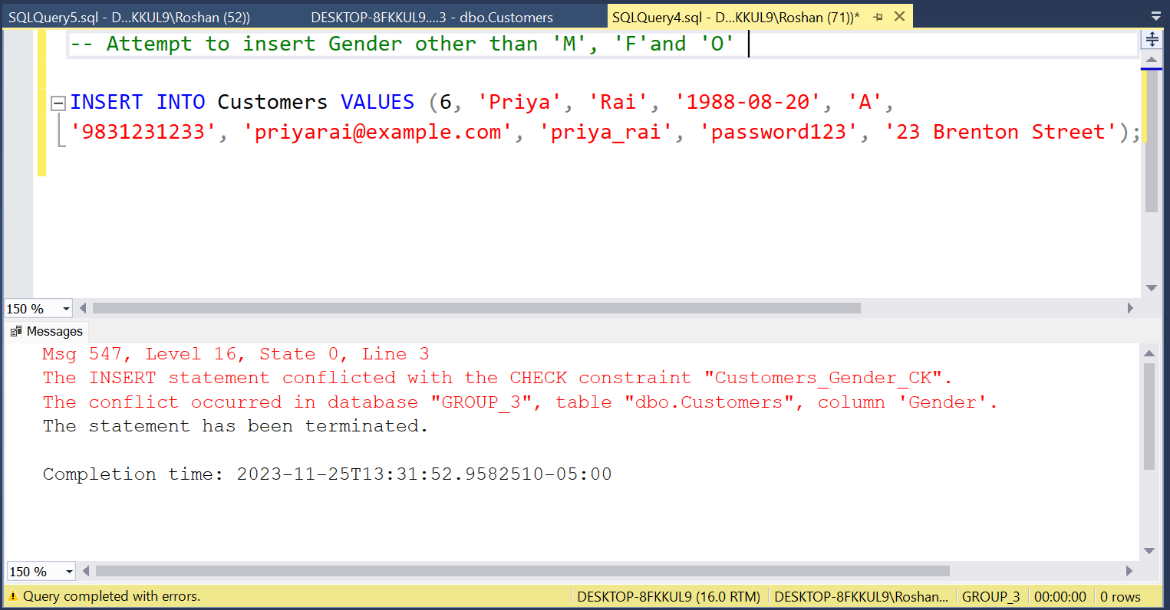

Figure Checking Gender Constraint

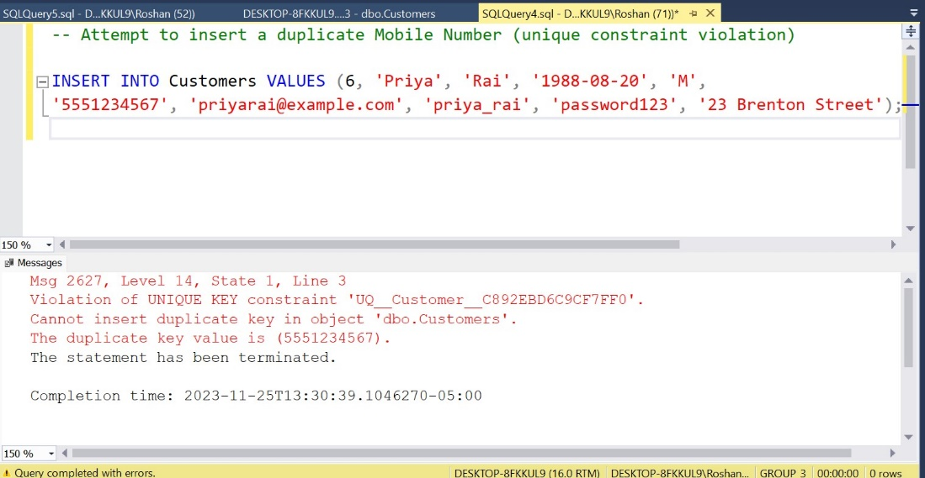

Figure Checking Unique Key Constraint for Mobile_Number

## Order Table

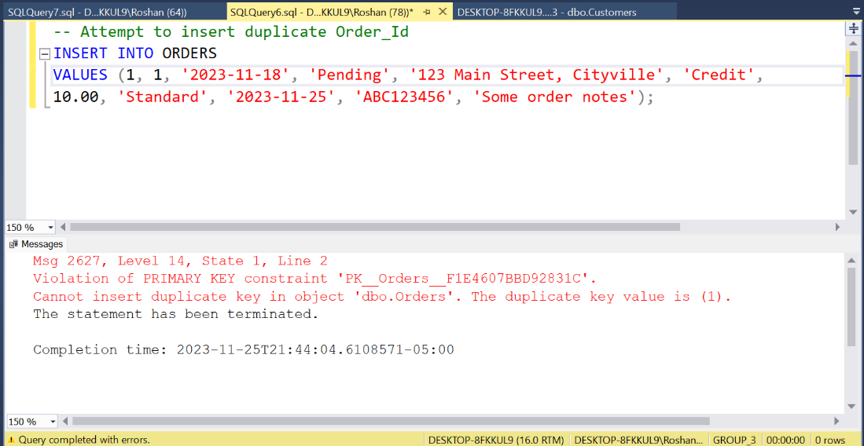

Figure Checking Primary Key Constraint for Order_Id

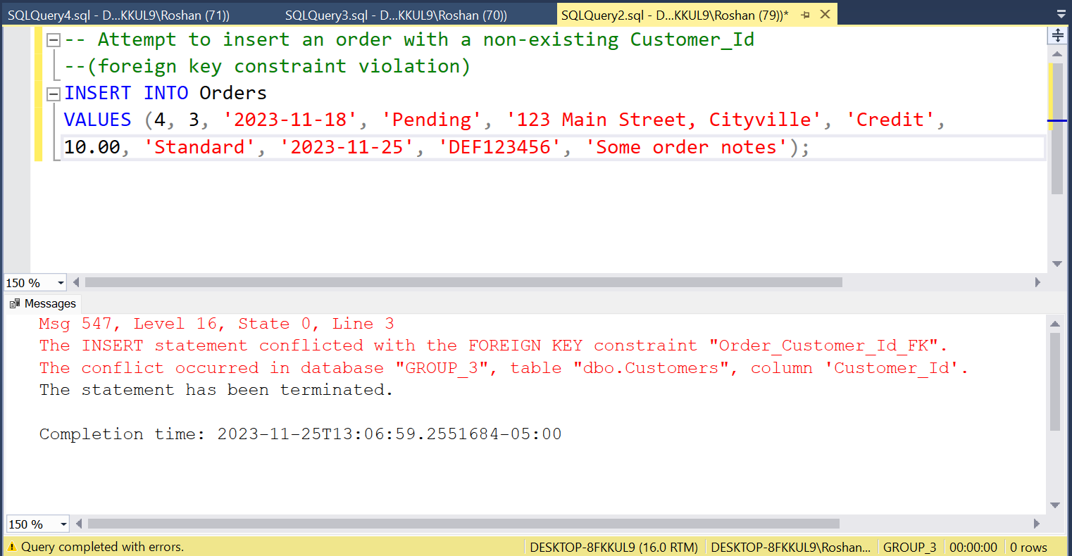

Figure Checking Foreign Key Constraint for Customer_Id

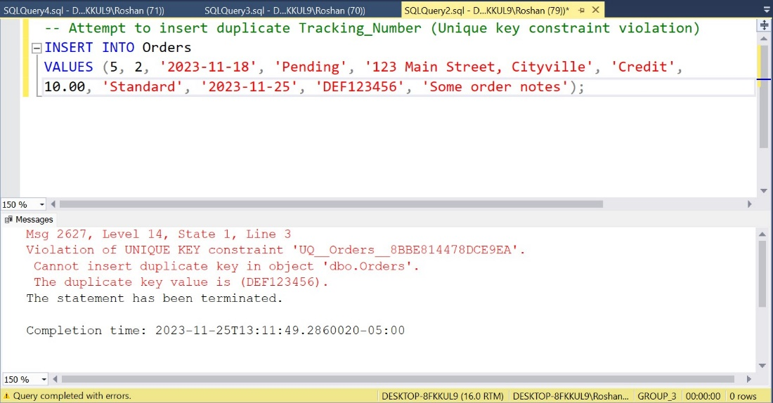

Figure Checking Unique Key Constraint for Tracking_Number

## Order_Items Table

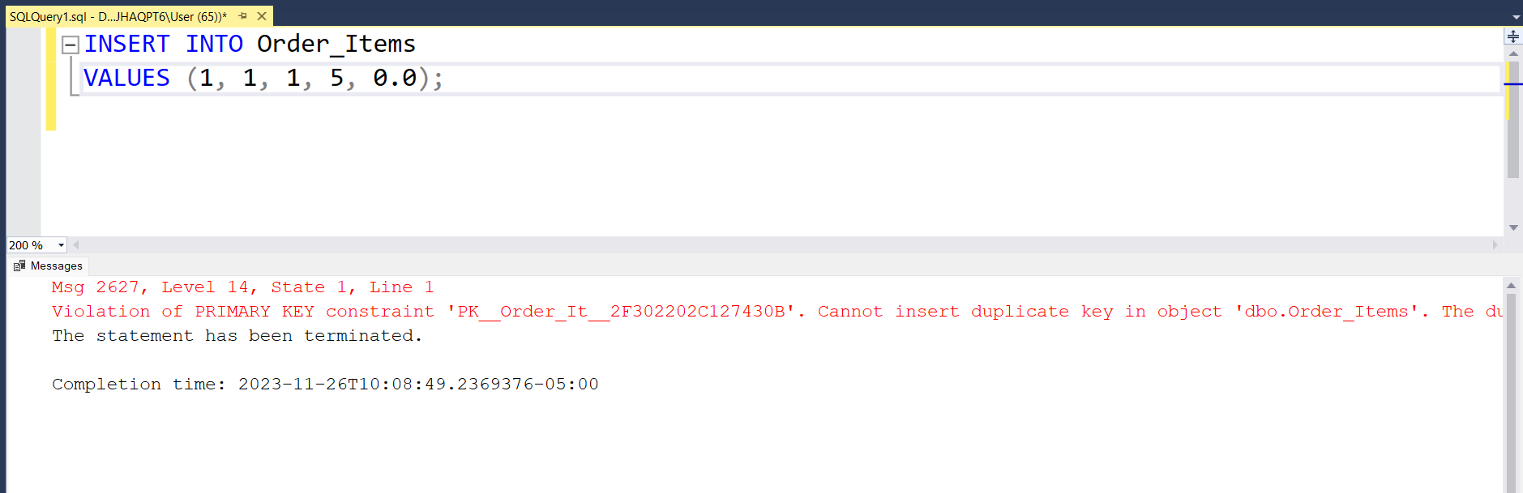

Figure Checking Primary Key Constraint

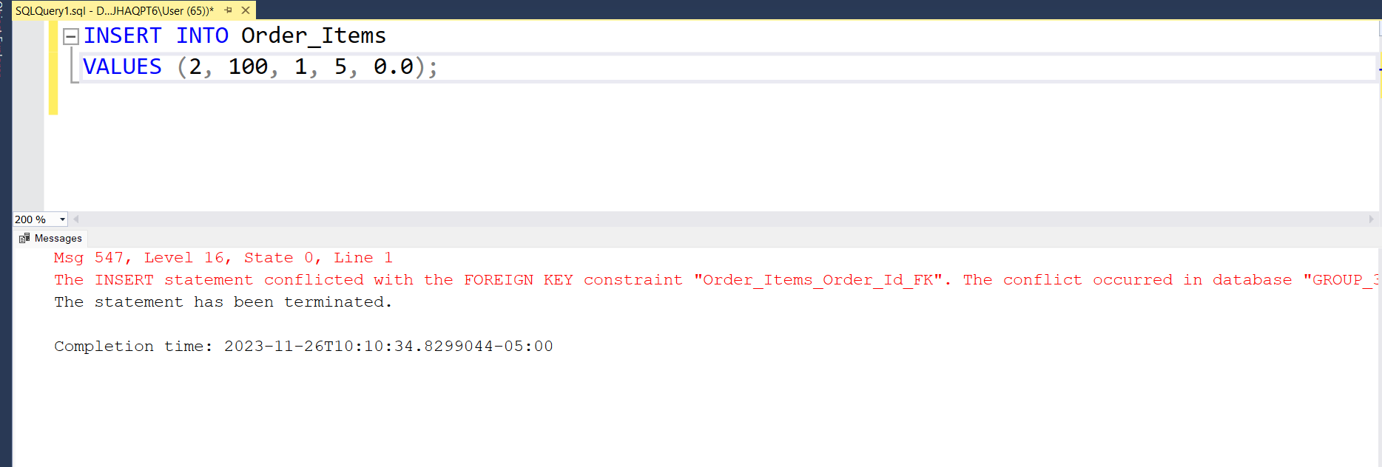

Figure Checking Foreign Key Constraint for Order_Id

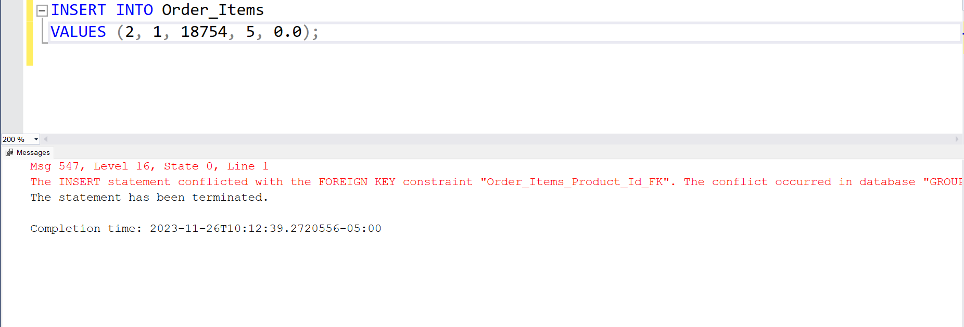

Figure Checking Foreign Key Constraint for Product_Id

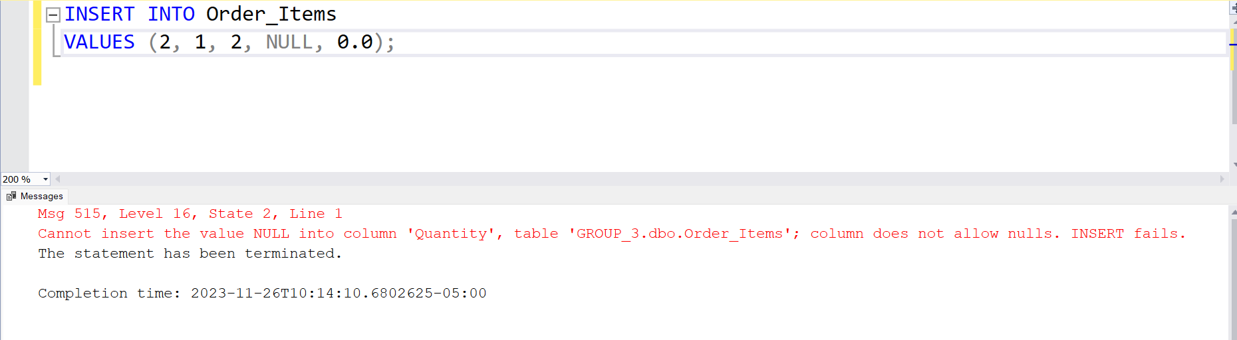

Figure Checking Not Null Constraint for Quantity

Figure Checking Not Null Constraint for Discount

## Company Table

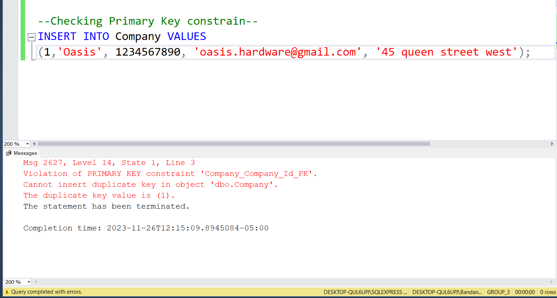

Figure Checking Primary Key Constraint for Company_Id

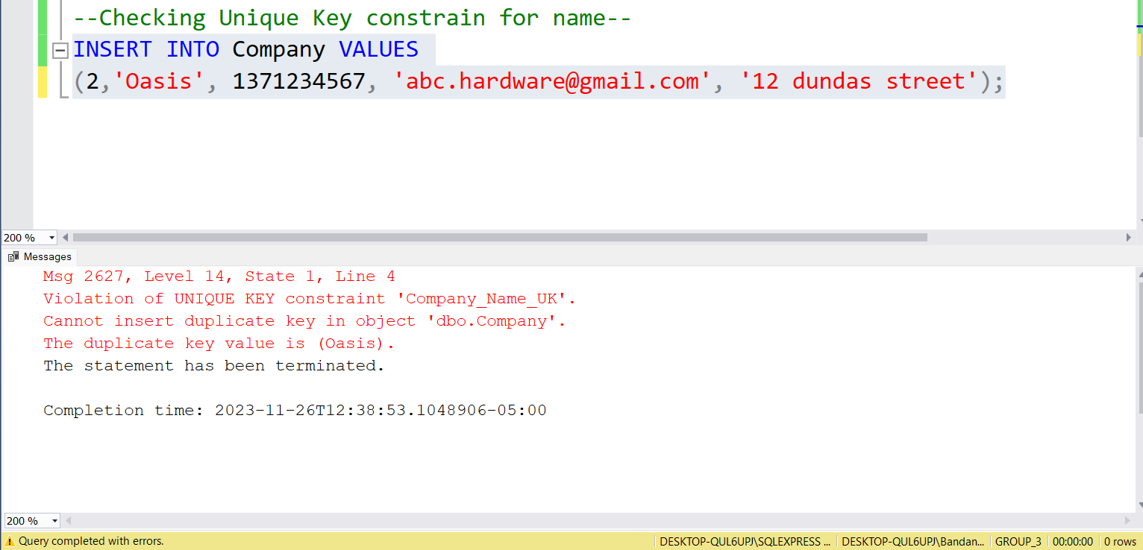

Figure Checking Unique Key Constraint for Name

Figure Checking Unique Key Constraint for Phone_Number

Figure Checking Unique Key Constraint for Email

## Warehouse Table

Figure Checking Primary Key Constraint for Warehouse_Id

Figure Checking Foreign Key Constraint for Warehouse_Manager_Id

Figure Checking Unique Key Constraint for Email

## Category Table

Figure Checking Primary Key Constraint for Category_Id

Figure Checking Unique Key Constraint for Name

## Inventory Table

Figure Checking Primary Key Constraint for Inventory_Id

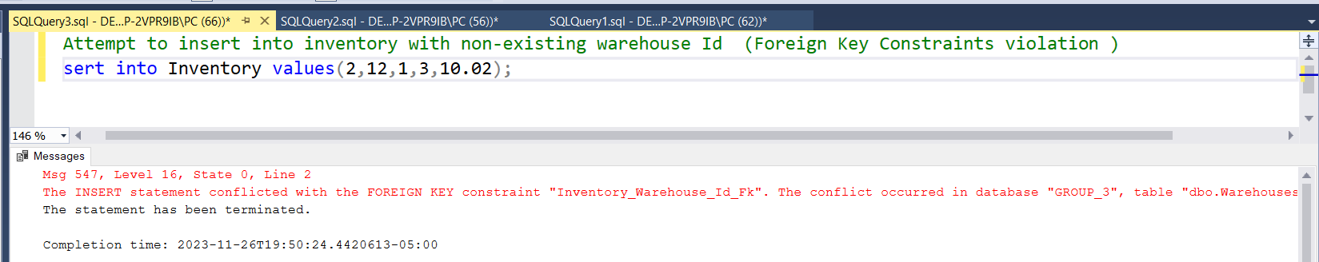

Figure Checking Foreign Key Constraint for Warehouse_Id

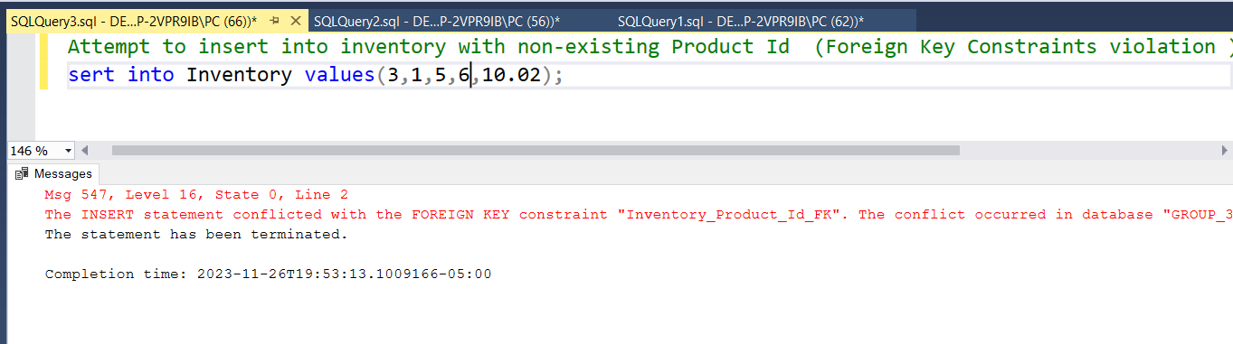

Figure Checking Foreign Key Constraint for Product_Id

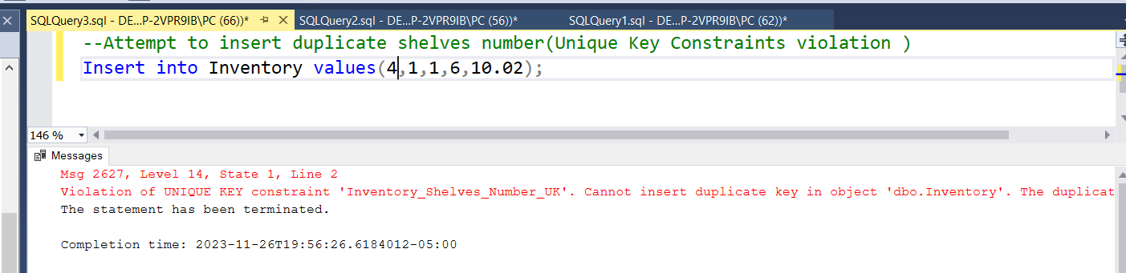

Figure Checking Unique Key Constraint for Shelves_Number